Catalyst Issues>>

- Submit New Lead>> Uploaded document type .ppt >> File type display is not correct in alert message.
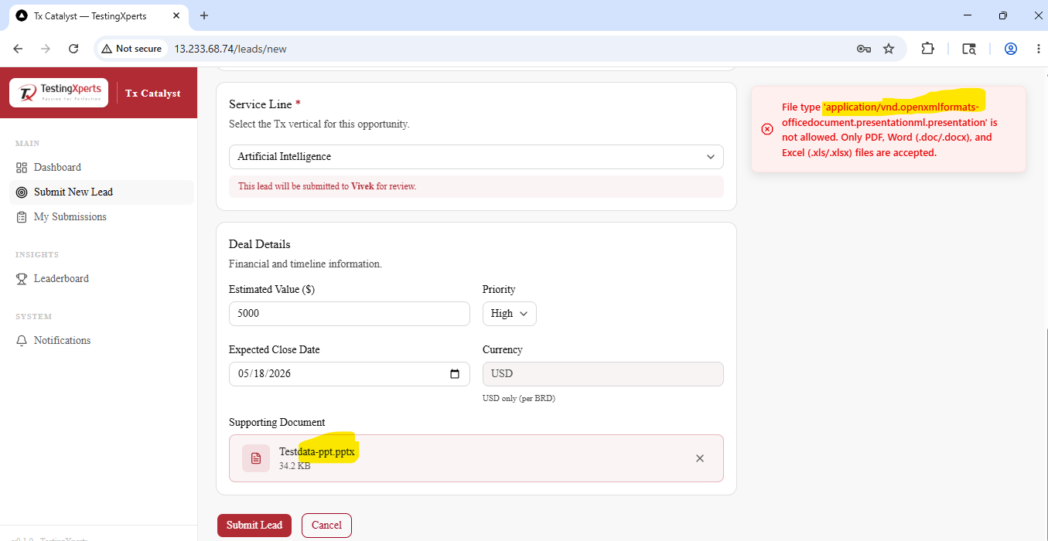

- Opportunity Created status does not exist in the Statuses list.

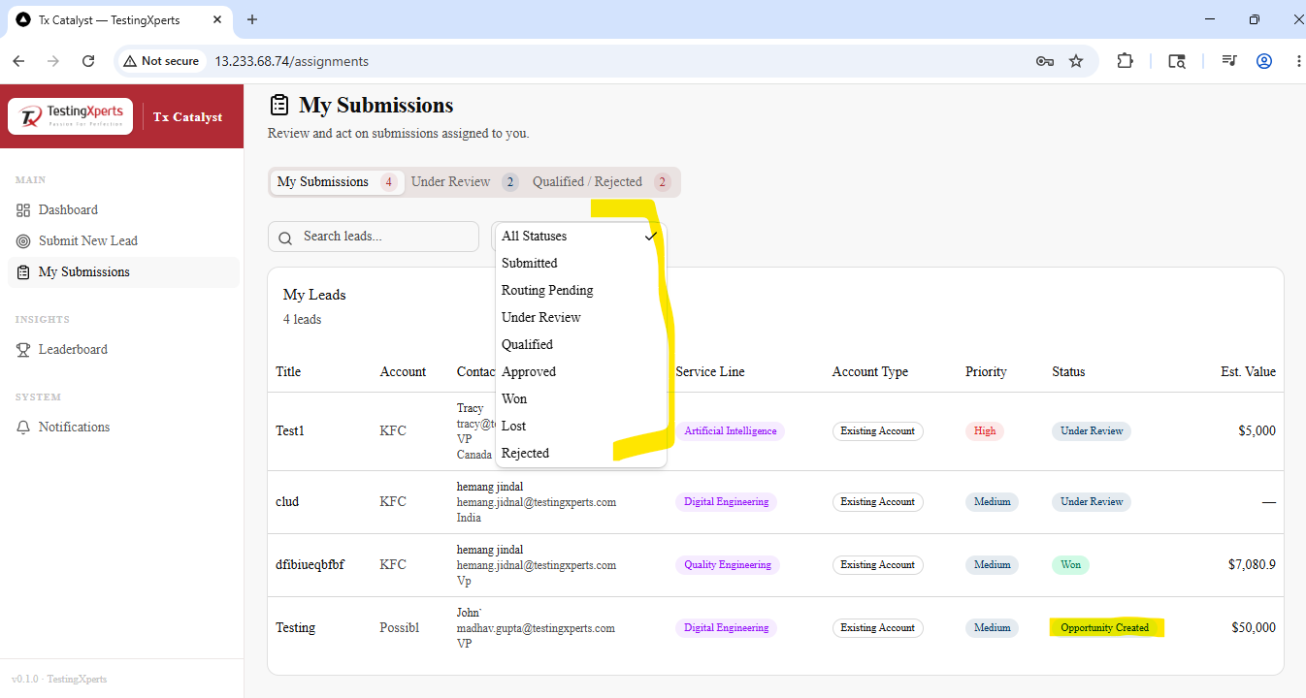

- Email >> View button>> On clicking button, user redirecting to localhost:
http://localhost:3000/leads/c0cc8fc9-85e2-4452-b2c5-ac4d038efa6a
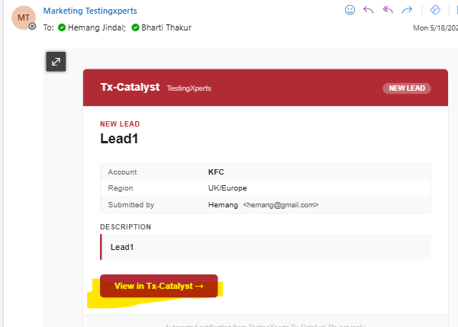

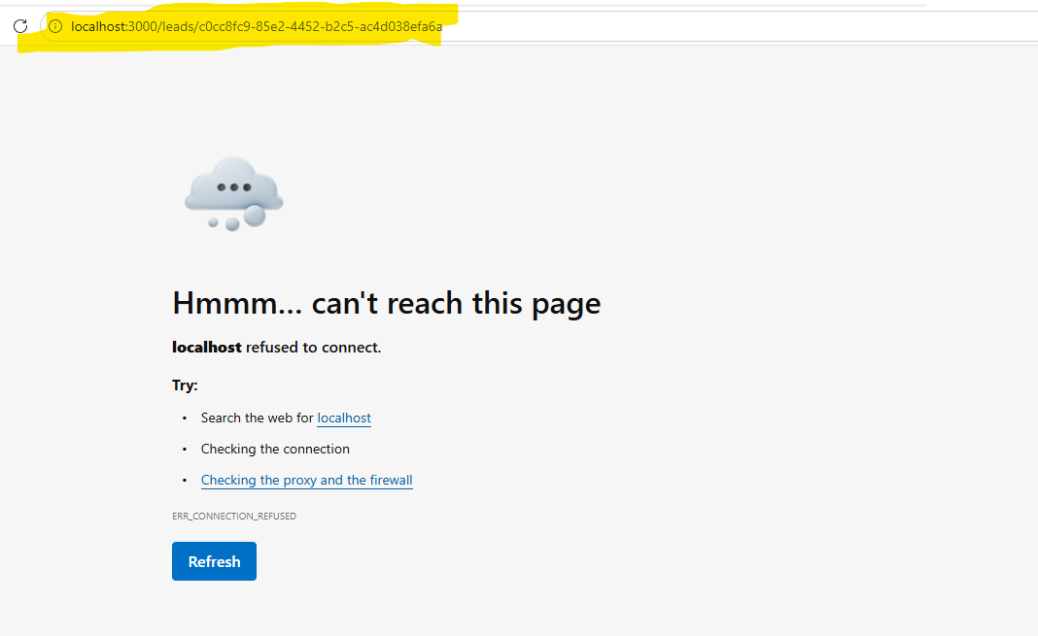

- Download document>> Invalid document displayed under downloads.
-> Document name, document type is incorrect.
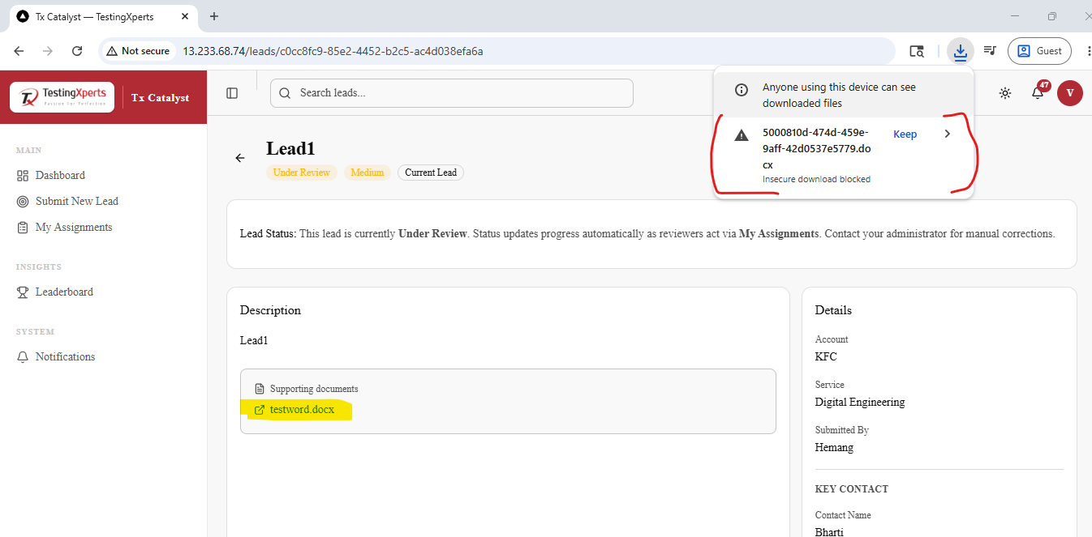

- Delete alert>> Heading display is not correct.
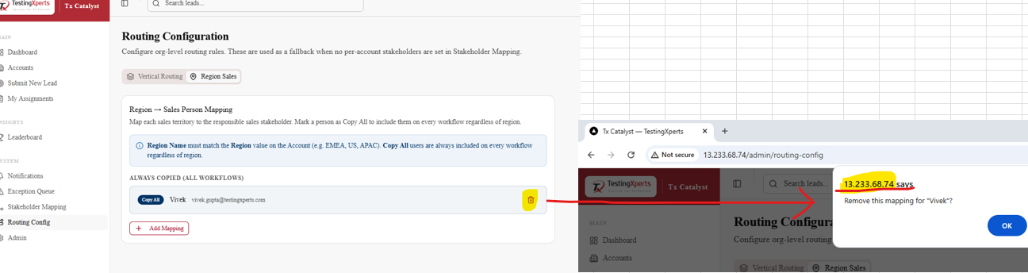
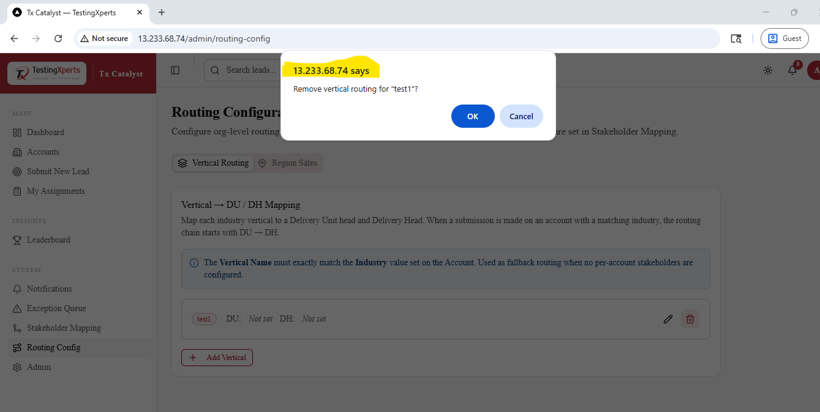
- Department is not displaying under User Management.
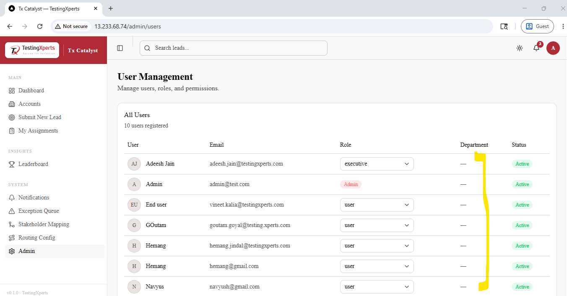

- Entered large, estimated value>> Request failed. >> Should display maximum estimated value alert / reason of request failed alert.
